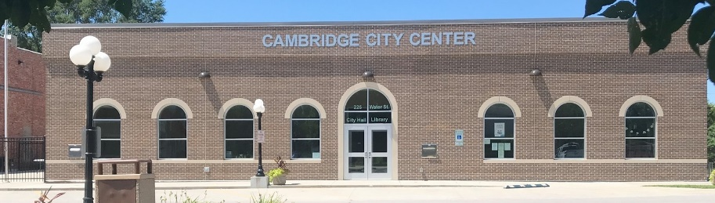

CITY COUNCIL MEETING NOTICE
MONDAY, JANUARY 9, 2023, 7:00 p.m.
Cambridge City Hall/Community Center

AGENDA

1) PLEDGE OF ALLEGIANCE-CALL TO ORDER REGULAR MEETING/ROLL CALL

2) APPROVE AGENDA AS PRESENTED AND/OR AMENDED

3) PUBLIC COMMENTS (5 Minute Time Limit for Items Not on This Agenda)

4) PRESENTATION: Steve Van Dyke, Fox Engineering – Race Street Storm Sewer Proposals

5) PRESENTATION: Greg Piklapp, Economic Development Director - Grant Opportunities and Feasibility Study of Opera House

6) CONSENT AGENDA – These are routine business items and will be acted upon by one Roll Call Vote without separate discussion unless a Council Member or citizen requests an item to be removed or considered separately.
a. Approve Minutes from December 12th Council Meeting.
b. Approve List of Claims
c. Approve Posting of Full-Time Utility Clerk/Office Assistant
d. Approve Posting of Full-Time Assistant Public Works Director

7) DEPARTMENT, COUNCIL AND MAYOR REPORTS
-Water
-Sewer/Solid Waste
-Roads
-Cemetery/Park/Library
-Finance/Economic Development
-Communications

8) BUSINESS ITEMS
a. City of Cambridge Employee Handbook
b. Opera House Update
*Realtor
c. City Code Update
-State Code (McBreen, Bassett, Baxter)
d. City Attorney
e. Set Date for Budget Work Session

9) MAYOR/COUNCIL COMMENTS

10) ADJOURNMENT

